A much easier way of obtaining values for K, a and b would be to use standard equations which are used in a simple RC circuit. As it is shown above, the transfer function is a 2nd order Laplace model (because a quadratic is used In the denominator D(s) of the transfer function) of a simple RC circuit, which produces a fall off of 40dB’s per decade.

The required cut off frequency is 6283 rad/s.

Using a differential equation to link the input voltage to the output voltage of the circuit.

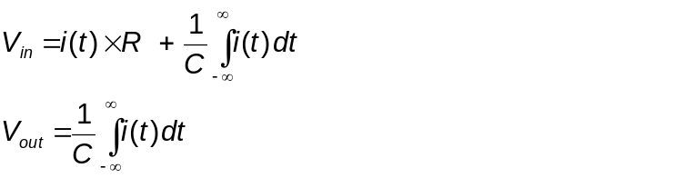

Knowing that the transfer function (H(s)) required to link the input and output voltage of the circuit is:-

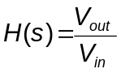

Using Laplace transforms on the time domain differential equation shown above. Transforming the equation into the frequency domain, will link the equation shown in give the required the required

Name of Question Sheet

By: David Clarke
Course: Electrical & Electronic Engineering2
Date:?/11/99

